Music Genre Classification (Spotify Dataset)

Hardik Gupta

M13474715

Contents

Executive Summary

Background

Problem Statement

Proposed Solution

Business Value

Data

Data Cleaning

Exploratory Data Analysis

Conclusion of Exploratory Data Analysis

Modelling

Conclusion

Executive Summary:

Background:

Music is the most popular art form that is performed and listened to by billions of people every day. There are many genres of music such as pop, classical, jazz, folk etc. Each genre has different music instruments, tone, rhythm, beats, flow etc. Digital music and online streaming have become very popular these days due to the increase in the number of users.

Genre classification is an important task with many real-world applications. As the quantity of music being released on a daily basis continues to sky-rocket, especially on internet platforms such as Soundcloud and Spotify – a 2016 number suggests that tens of thousands of songs were released every month on Spotify – the need for accurate meta-data required for database management and search/storage purposes climbs in proportion. Being able to instantly classify songs in any given playlist or library by genre is an important functionality for any music streaming/purchasing services it helps them to curate new playlists and make recommendations to their users based on their preferences and history.

Problem Statement :

Categorizing songs according to their genre, using certain audio features provided by Spotify.

Proposed Solution:

1. Perform exploratory data analysis to isolate important audio features or predictors which will help to classify the songs.
2. Build a classification model using Linear Discriminant Analysis, Decision trees, and Random Forest techniques for accurately predicting the genre of music.

Business Value:

Recommendation systems built by various music streaming services using machine learning help to them to classify songs.

Data:

* This data comes from Spotify via the [spotifyr package](https://www.rcharlie.com/spotifyr/). [Charlie Thompson](https://twitter.com/_RCharlie), [Josiah Parry](https://twitter.com/JosiahParry), Donal Phipps, and Tom Wolff authored this package to make it easier to get either your own data or general metadata arounds songs from Spotify's API.
* This dataset was uploaded on [GitHub](https://raw.githubusercontent.com/rfordatascience/tidytuesday/master/data/2020/2020-01-21/spotify_songs.csv) as a part of TidyTuesday by R community, which was created to provide individuals with datasets to practice R skills.
* There are total 32833 observations in 23 variables.
* There are 12 audio features for each track, including confidence measures like acousticness, liveness, speechiness, instrumentalness, and perceptual measures like energy, loudness, danceability, and valence (positiveness), and descriptors like duration, tempo, key, and mode.

We have made use of these 12 audio features for our prediction, description of these variables are as follows:

|  |  |  |
| --- | --- | --- |
| playlist_genre | character | Playlist genre |
| danceability | double | Danceability describes how suitable a track is for dancing based on a combination of musical elements including tempo, rhythm stability, beat strength, and overall regularity. A value of 0.0 is least danceable and 1.0 is most danceable. |
| energy | double | Energy is a measure from 0.0 to 1.0 and represents a perceptual measure of intensity and activity. Typically, energetic tracks feel fast, loud, and noisy. For example, death metal has high energy, while a Bach prelude scores low on the scale. Perceptual features contributing to this attribute include dynamic range, perceived loudness, timbre, onset rate, and general entropy. |
| key | double | The estimated overall key of the track. Integers map to pitches using standard Pitch Class notation . E.g. 0 = C, 1 = C♯/D♭, 2 = D, and so on. If no key was detected, the value is -1. |
| loudness | double | The overall loudness of a track in decibels (dB). Loudness values are averaged across the entire track and are useful for comparing relative loudness of tracks. Loudness is the quality of a sound that is the primary psychological correlate of physical strength (amplitude). Values typical range between -60 and 0 db. |
| mode | double | Mode indicates the modality (major or minor) of a track, the type of scale from which its melodic content is derived. Major is represented by 1 and minor is 0. |
| speechiness | double | Speechiness detects the presence of spoken words in a track. The more exclusively speech-like the recording (e.g. talk show, audio book, poetry), the closer to 1.0 the attribute value. Values above 0.66 describe tracks that are probably made entirely of spoken words. Values between 0.33 and 0.66 describe tracks that may contain both music and speech, either in sections or layered, including such cases as rap music. Values below 0.33 most likely represent music and other non-speech-like tracks. |
| acousticness | double | A confidence measure from 0.0 to 1.0 of whether the track is acoustic. 1.0 represents high confidence the track is acoustic. |
| instrumentalness | double | Predicts whether a track contains no vocals. “Ooh” and “aah” sounds are treated as instrumental in this context. Rap or spoken word tracks are clearly “vocal”. The closer the instrumentalness value is to 1.0, the greater likelihood the track contains no vocal content. Values above 0.5 are intended to represent instrumental tracks, but confidence is higher as the value approaches 1.0. |
| liveness | double | Detects the presence of an audience in the recording. Higher liveness values represent an increased probability that the track was performed live. A value above 0.8 provides strong likelihood that the track is live. |
| valence | double | A measure from 0.0 to 1.0 describing the musical positiveness conveyed by a track. Tracks with high valence sound more positive (e.g. happy, cheerful, euphoric), while tracks with low valence sound more negative (e.g. sad, depressed, angry). |
| tempo | double | The overall estimated tempo of a track in beats per minute (BPM). In musical terminology, tempo is the speed or pace of a given piece and derives directly from the average beat duration. |
| duration_ms | double | Duration of song in milliseconds |

Data Cleaning :

For the purpose of this study, we were only interested in the genres and audio features used to predict the genre so all the irrelevant columns were removed from the dataset and only the relevant ones were kept.

Apart from this data did not have any missing values or bad data so any more data cleaning was not required.

Exploratory Data Analysis:

1. Basic structure and head of data

1. Genres

We can see that EDM has the greatest number of songs, followed by Rap and then other genres.

1. Next, we plot the density graphs of the audio features with all the genres to see which features can help us in our classification. 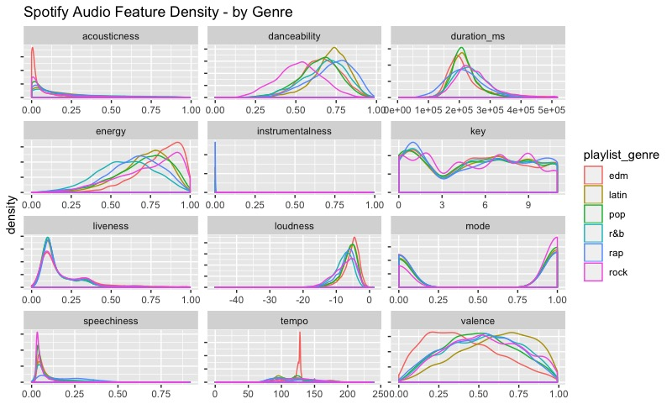

Breaking things out by genre, EDM tracks are least likely to be acoustic and most likely to have high energy with low valence (sad or depressed);Latin tracks have high valence (are positive or cheerful) and danceability; Rap songs score highly for speechiness and danceability; and Rock songs are most likely to be recorded live and have low danceability. Pop, Latin and EDM songs are more likely to have shorter durations compared to R&B, Rap, and Rock

Based on the density plot, it looks like energy, valence, tempo and danceability may provide the most separation between genres during classification, while instrumentalness and key may not help much.

1. Next to further our investigation we plot boxplots of our shortlisted variables or audio features.

Insights obtained from density and boxplots:

1. Valence - As observed in the density plot valence can provide us a good separation between EDM and Latin tracks as there is a considerable difference between their medial values and range, while all other genres have somewhat similar valence.

2. Energy - Latin and Pop tracks have similar range and median values so energy might not be a good separator for them while the remaining 4 genres have a decent separation on energy.

3. Danceability - As density plots show Rock has the lowest danceability score while Latin tracks are more closely packed with the high danceability scores and Rap have a little more variability than Latin tracks but in general have high danceability score.

4. Tempo - It might do a good job of separating EDM tracks from the rest of the genres as most of the EDM tracks are clustered around 125 while other genres have more or less a similar spread and variability.

1. Next we go ahead and check the correlation amongst all the audio features

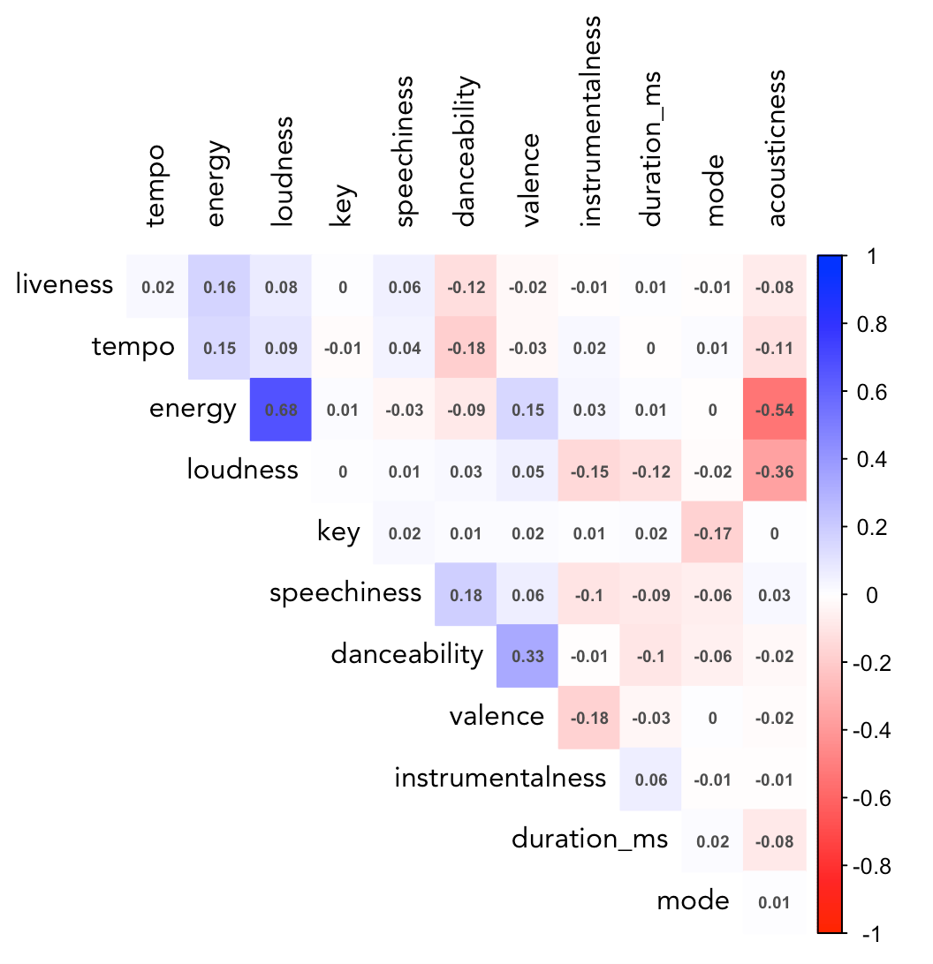

Across all songs and genres in the dataset, energy and loudness are fairly highly correlated (0.68). Let's remove loudness, since energy appears to give more distinction between genre groups (as seen in the density plot).

Energy and acousticness are negatively correlated, which makes sense, along with the positive correlation between danceability and valence (happier songs lead to more dancing). Liveness, tempo, and energy are clustered together, as are speechiness and danceability. Interestingly, danceability is negatively correlated with tempo and energy.

1. Next we plotted correlation between the genres to see if this could cause any troubles or help us in classification.

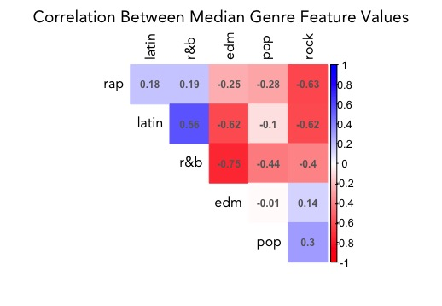

Rock and EDM is negatively correlated with all genres except for each other, which may make them easy to tell apart from the rest of the genres, but not each other. Latin and R&B are the most similar, with a positive correlation of 0.57, while EDM and R&B and EDM and Latin are the most different (-0.75, -0.62).

Conclusion of Exploratory Data Analysis:

Based on our above analysis we decided to go ahead with 5 important audio features to use in our models.

1. Valence
2. Speechiness
3. Tempo
4. Energy
5. Danceability

Modelling

We decided to use Decision Trees, Random Forest and Linear Discriminant Analysis for classification purposes, as the separability from audio features was not very good, we decided to go for Linear Discriminant Analysis.

For modelling purpose, we divided our dataset in to training (80%) and testing (20%).

songs.train – 26266 observations

songs.test – 6567 observations

1. Linear Discriminant Analysis

Training Data

Prediction:

In our training data set we got a misclassification rate of 57%.

Now on Test Data

We get a misclassification rate of 58%, which means our model correctly predicted 42% of the data.

1. Decision Trees

On Training Data

1. According to the tree Speechiness is the most important feature separating Rap from rest of the genres, tracks with low danceability are classified as Rock.

2. High Tempo tracks are either classified as EDM or RAP with higher tempo songs being classified as Rap, this observation is in line with our Boxplot as it shows that both rap and edm have high tempo while rap has a larger range, edm tracks are closely packed around their mean.

3. Values under the leaves represents the true values of each genre grouped into that leaf, for example, 10% EDM tracks, 14% Latin, 7% pop, 20% R&B, 46% Rap, and 2% Rock have been classified as Rap. Similar for all the other leaves.

4. Best classification was achieved for EDM with 56% correctly classified and second best was Rap with 46%.

Decision tree on Test Data

Decision tree was able to correctly predict 37% values in our test data.

1. Random Forest

Training Data

Predictions on our training set gives 94% accuracy.

Testing Data



While predictions our test data gives us an accuracy of 49% which is the best amongst all the models we have used.

Conclusion:

Based on the results from our 3 models we observe that Random Forest gives us the best result of 49%.

Below table shows how our 3 models predict individual genres.

Rock, EDM and Rap are the easiest to classify amongst all the genres in our dataset.

